|  |  |  |  |
| --- | --- | --- | --- |
|  | Bansilal Ramnath Agarwal Charitable Trust's  Vishwakarma Institute of Information Technology  **Department of**  **Artificial Intelligence and Data Science** | | |
| Name: Siddhesh Dilip Khairnar | | | |
| Class: SY | Division: B | | Roll No: 272028 |
| Semester: III | | Academic Year: 2022-2023 | |
| Subject Name & Code: Database Management System: ADUA21204 | | | |
| Title of Assignment: Implement Map reduce operation with suitable example using MongoDB. | | | |

**Assignment No.- 09**

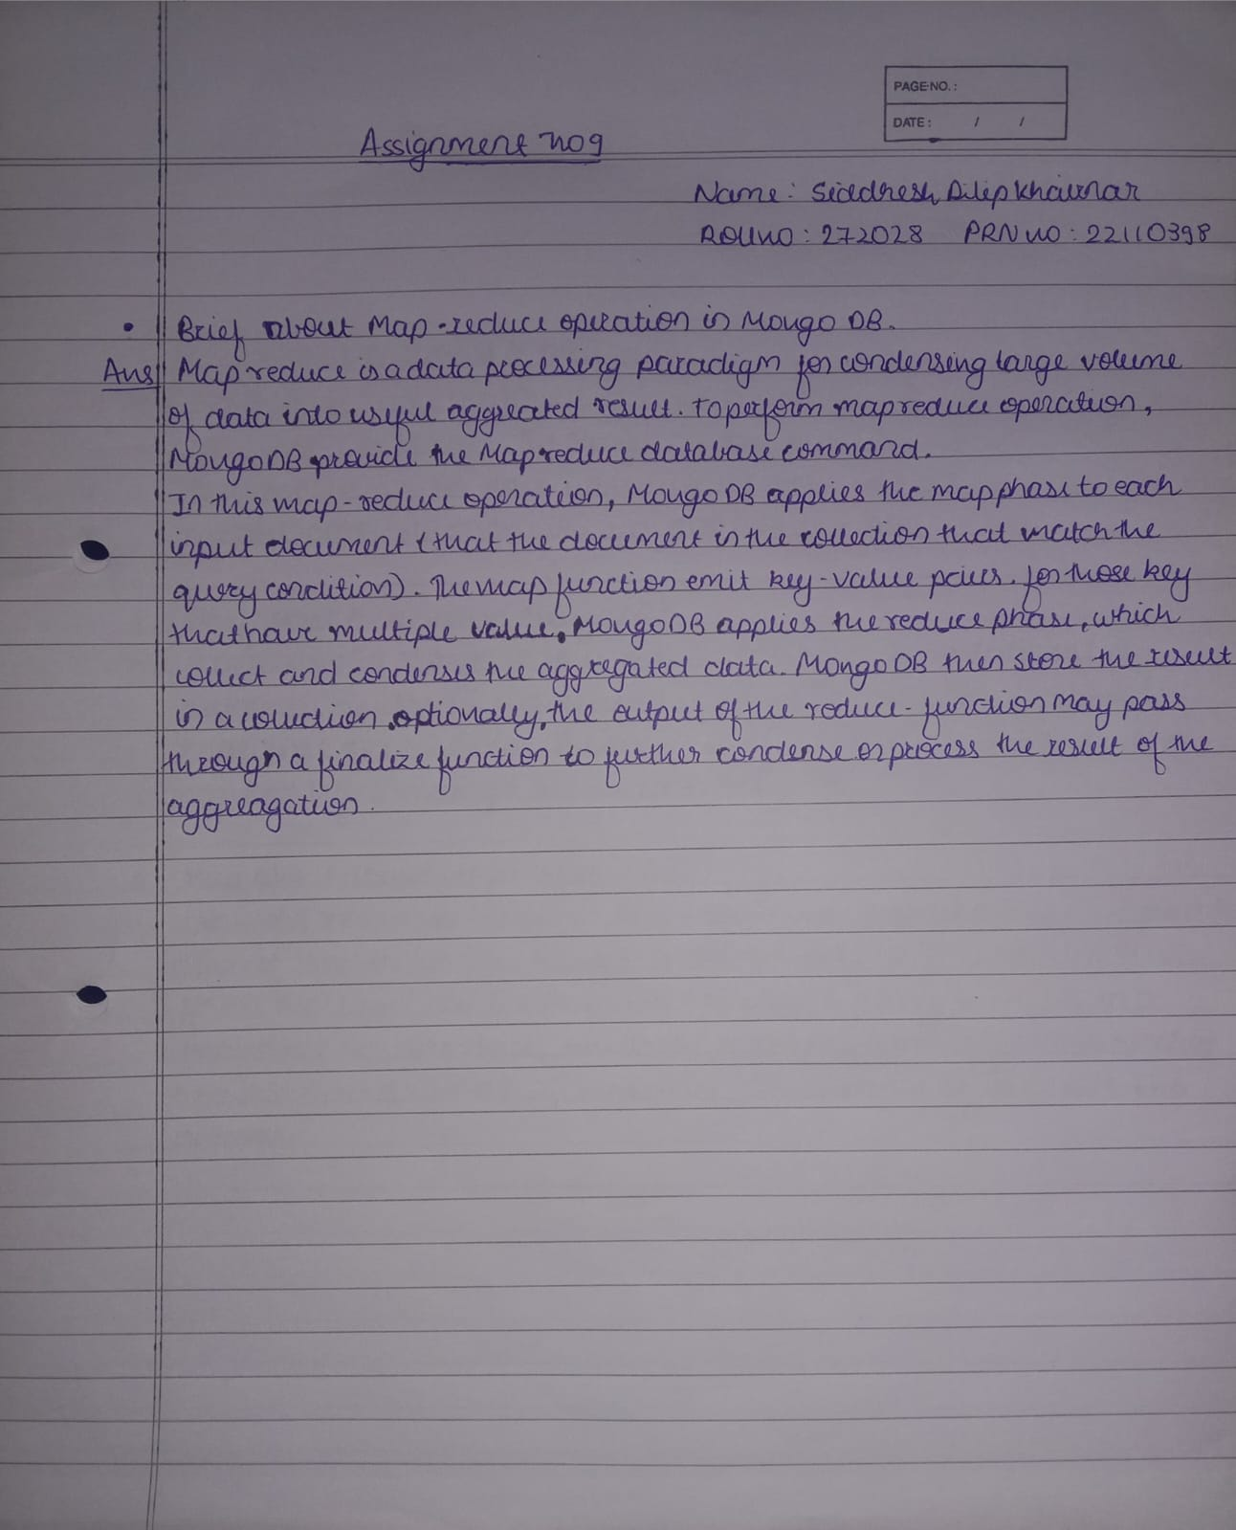

**Implementation:**

**Below collection will be used for the operations**

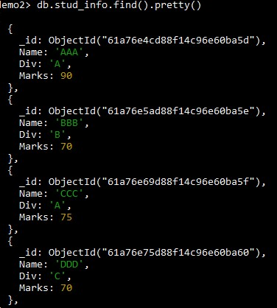

1. Calculates total marks in each division

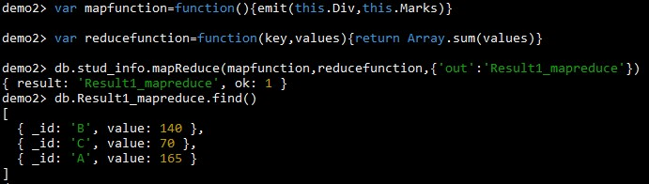

1. Calculate average marks in each division

